STLC (Software testing life cycle):

In order to conduct system testing organization follow one testing Life cycle called STLC

Phases of STLC :🡪

Test initiation

Test Planning

Test design

Test execution

Defect Tracking

Defect Reporting

Result analysis

Test closure

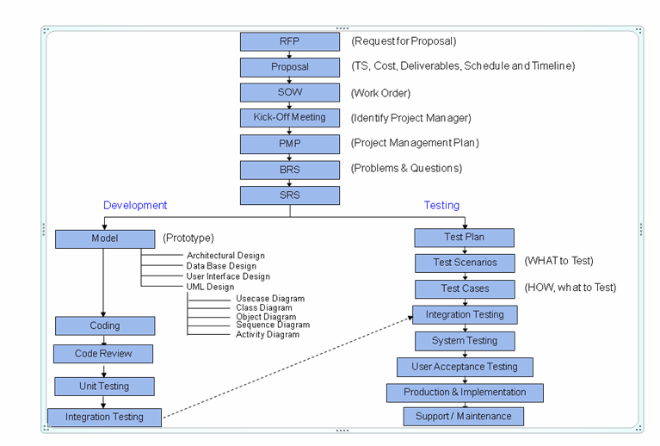

Test strategy:🡪

In general software testing process starts with initiation stage. In this stage project manager and test manager prepare the strategy document.

Software testing strategies:

* Exhaustive test strategy
* Planned optimal strategy
* Ad-hoc test strategy

Exhaustive testing is impossible Due to this reason organization follow the optimal test strategy. Some time testing team follows the Ad-hoc testing strategy.

Note:🡪

In Agile process organizations follow Ad-hoc strategy.

**Optimal test strategy document format:**

In general, PM /TM category people can prepare test strategy document in IEEE format 829. 829 indicate for software testing.

Scope and objective:

Importance of current project to customer and company. Here they prepare strategy for testing team and development team.

Testing budget allocation:🡪

What is budget allocated for testing :🡪

Development and Maintenance: 64%

Testing: 36%

What is deadline for testing:🡪

Start-time: End-time:

Test responsibility metrix:

Specifies the list of responsible S\w topics in s\w testing

[Functional & API Testing, Performance ]

Roles and responsibilities:

Names of jobs in testing team and responsibility of each role

Test lead:

Prepare Test plan and review test cases designed by test engineer and coordinate to PM and test engineer.

SR. Test Engineer:

Prepare test cases and coordinate jr. Tester and test lead

Jr. Test Engineer: Run test cases on SUT (Software under test)

Report defects and design cases.

Automation Team: Design automation tests and schedule

Them to run without human involvement.

Communication and status reporting:

Required negotiation channels in between every two jobs in testing team. [Teams]

Test Automation and testing tools:

* + Need for automation current project and available tools.
  + Selenium, Postman , Load Runner

Defect Reporting and tracking:

Required negotiation channels in between testers and developers while reporting defects.

Defect reporting tools: Jira, Quality Center, Yodiz, P-Tracker

Test Management tools:

Management tools to manage Manual and automation testing

* Quality Center, Test Link, JIra ,Test rail

Configuration management:

* + In the above configuration repository development based documents like BRS, SRS, HLD, LLDs source code…etc.

Will be deploy throw configuration management tools only

Management tolls maintain versions. And also we can deploy testing related documents test strategy, test plan, test cases, defect reporting.

Example: Visual source safe 6.0, Clear quest

Cloud base repositories:🡪 git, Bit bucket

Training plan:

Need for training to testers on current project required any technical training.

Testing team formation:

Availability of testers on the bench

Available test duration in current project

Available of testing tools

Risks and Assumptions:

List of risks or challenges will come during testing and solution to overcome them.

Any Environment issue, Lack of resource, tester doesn’t have technical knowledge.